Assignment 2

Solution 1)Dice Roller Application

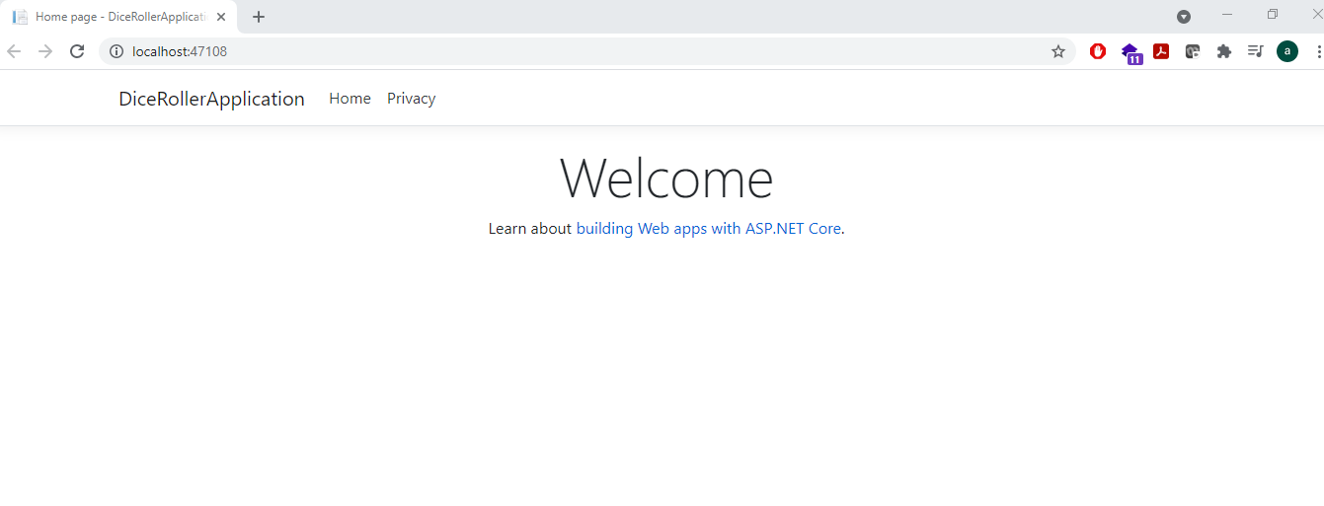

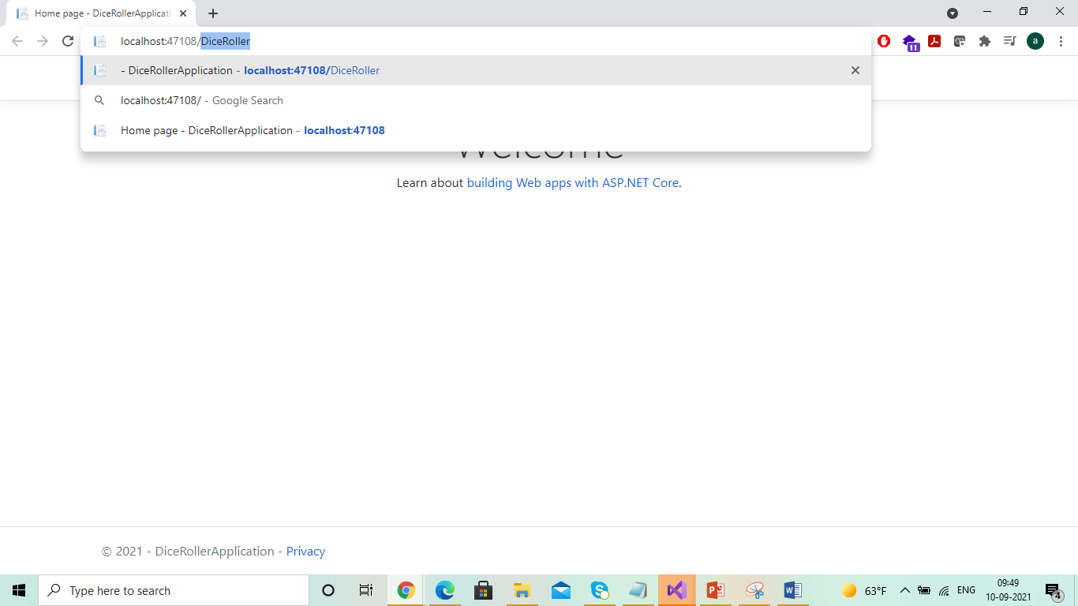

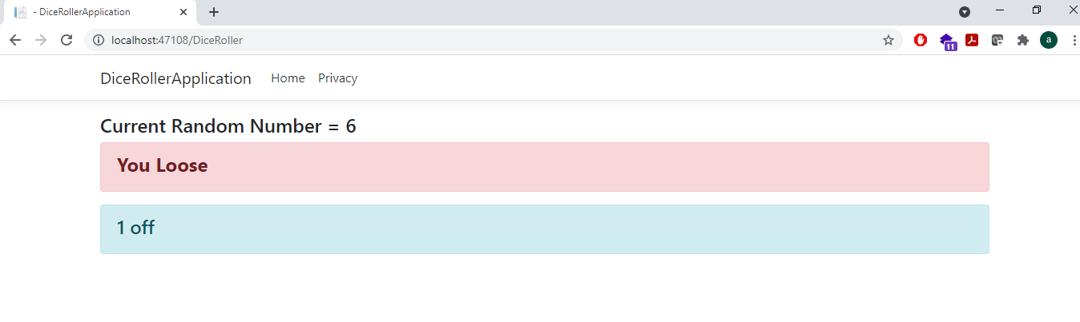

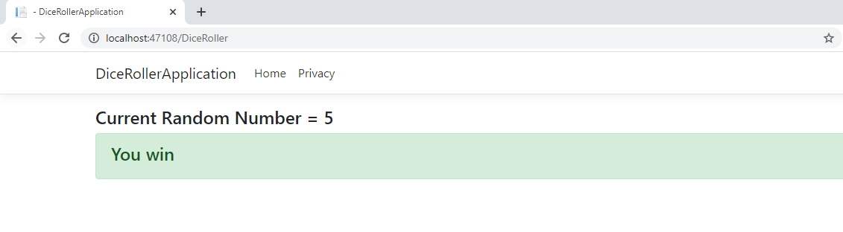

CODE Dump:

@page

@model DiceRollerApplication.Pages.DiceRollerModel

@{

int randomNumber = new Random().Next(1, 7); //GENERATES NUMBER BETWEEN 1 and 6

int winningNumber = 5;

}

<h4>Current Random Number = @randomNumber</h4>

@if (randomNumber == winningNumber)

{

<div class="alert alert-success">

<h4>You win</h4>

</div>

}

else

{

<div class="alert alert-danger">

<h4><strong>You Loose</strong></h4>

</div>

@if (randomNumber > winningNumber)

{

<div class="alert alert-info">

<h4>@(randomNumber - winningNumber) off</h4>

</div>

}

else

{

<div class="alert alert-info">

<h4> @(winningNumber - randomNumber) off</h4>

</div>

}

}